Name: ____________________
Functions Worksheet

FOR EACH:
Is it a function? Explain why or why not.
0
2
4
6
8
0

2

4
x | y
-6 | 2
-3 | 2
0 | 2
4 | 2
8 | 2

1) 2) 3) (-8, 4) (3, 7) (5, 6) (3, -8) (1, 2)

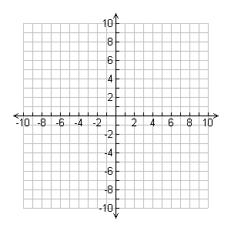
4) 5) 6)

7) Input = Word; Output = Number of vowels in the word

8) Input = Meigs teacher; Output = Student who has that teacher for homeroom

9) Input = Any number; Output = Absolute value of that number

