Basics of Geometry III

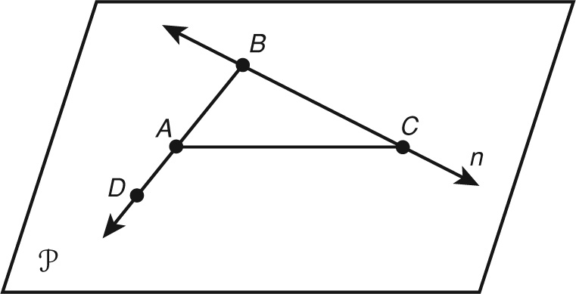**Use the picture for 1-4.**

1. Name a line. \_\_\_\_\_\_\_\_\_\_\_\_\_

2. Name a segment on line *n*. \_\_\_\_\_\_\_\_\_\_\_\_\_\_\_

3. Name a ray with endpoint *A*. \_\_\_\_\_\_\_\_\_\_\_\_\_\_\_

4. Name the plane. \_\_\_\_\_\_\_\_\_\_\_\_\_\_\_

**Sketch each figure for 5-6.**

5. two rays that form a straight line and that intersect at point P.

6. two line segments that both have a midpoint at point M.

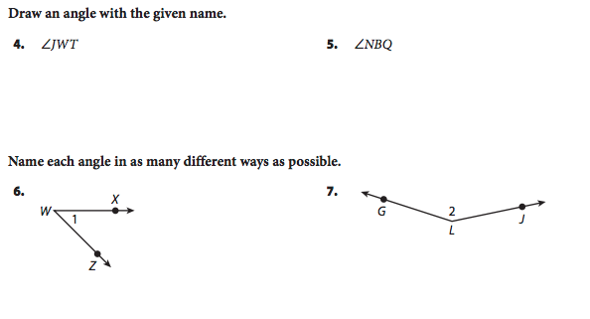

7. Name the angle in as many ways as possible.

**Determine the measure of each angle. Then describe each angle as acute, right, obtuse, or straight.**

|  |  |  |
| --- | --- | --- |
| 8.  GE_MTXEDI363113_032T  m∠ABC  \_\_\_\_\_\_\_\_\_\_\_  \_\_\_\_\_\_\_\_\_\_\_\_\_\_\_\_\_\_\_\_\_\_ | 9.  GE_MTXEDI363113_033T  m∠DEF  \_\_\_\_\_\_\_\_\_\_\_  \_\_\_\_\_\_\_\_\_\_\_\_\_\_\_\_\_\_\_\_\_\_ | GE_MTXEDI363113_034T 10.  m∠KLM  \_\_\_\_\_\_\_\_\_\_\_  \_\_\_\_\_\_\_\_\_\_\_\_\_\_\_\_\_\_\_\_\_\_ |

11. *S* is the midpoint of  *RS* = 2*x* + 4, and *RT* = 8*x*. Find *ST*.

12. R, S, and T are collinear, and S is between R and T. If *RS* = x + 1, *ST* = 2x − 2, and *RT* = 5x − 5, find *RT*.

13. bisects ∠*WXY*, and m∠*WXZ* = 90°. Find m∠*WXY*.

14. m∠*PQR* if QT bisects ∠*PQR*, m∠*RQT* = (10*x* − 13)°, and m∠*PQT* = (6*x* + 1)°.

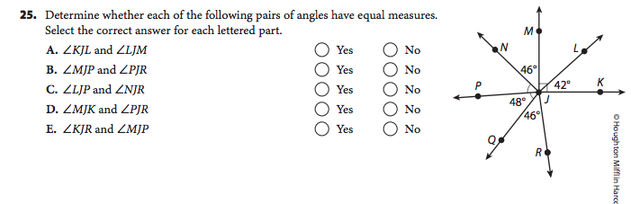15.