Geometry Homework II
- Find the value of y, given that m∠MLK=135°

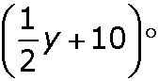
- BD bisects ∠ABC, m∠ABD = , and m∠DBC = (y + 4)°. Find m∠ABC.

4. Solve $m=\frac{h-w}{8}$ for the variable h.

3. Simplify:
$$4\left(\frac{1}{2}+\frac{5}{4}\right)+ -5=$$

Use the angle pictured for 5-7
5. An angle is a figure formed by two rays with a common
endpoint called the ____________.
6. Name the two rays that form ∠P.

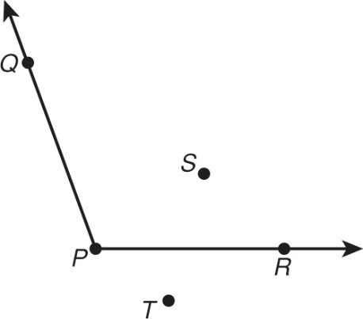
7. Use the angle symbol and three letters to name ∠P in two ways.

Complete the statement.
8. A tool used to measure and draw angles
is called a .
Find the measure of each angle using the protractor pictured. Then tell whether
each is acute, right, obtuse, or straight.
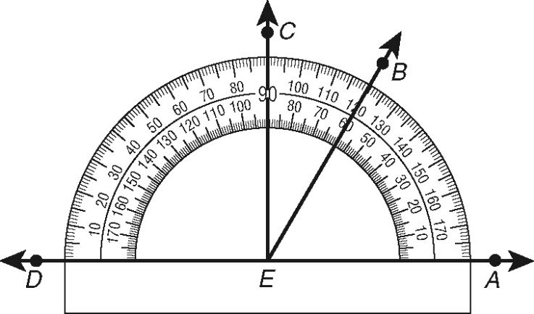
9. ∠CEA

10.∠AEB

11. ∠DEA

