Exponentials Review
Tell whether the ordered pairs satisfy an exponential function. Explain your answer.
1. 2. 3.
x | y
−4 | 1.5
−3 | 3
−2 | 6
−1 | 12

x | y
−2 | −2
−1 | −10
0 | −50
1 | −250

x | y
1 | 1
2 | 2
3 | 6
4 | 24

4. {(1,10), (2, 20), (3, 40), (4, 80)} __________________________________________________________

5. {(1,5), (2, 10), (3, 15), (4, 20)} __________________________________________________________

For 6-11,
1. Is it Linear or Exponential?
2. Write the Equation for the Table

6. 7. 8.
x | y
−4 | 16
−3 | 20
−2 | 24
−1 | 28

x | y
−2 | 100
−1 | 10
0 | 1
1 | 1/10

x | y
-2 | 2/3
-1 | 2
0 | 6
1 | 18

x | y
0 | 2
1 | 11
2 | 60.5
3 | 332.75

x | y
2 | 6
3 | 10
4 | 14
5 | 18

x | y
−2 | 9
−1 | 18
0 | 27
1 | 36

9. 10. 11.

Graph the Following Functions.

12. y = −4 (0.5)^{x} 13. y = 2 (5)^{x} 14. y = (2)^{x} – 3
x | y
−1
0
1
2

x | y
−1
0
1
2

x | y
−2
−1
0
1

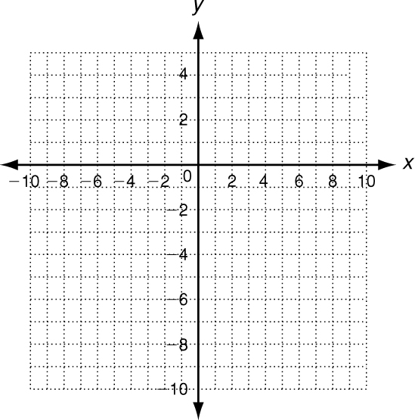
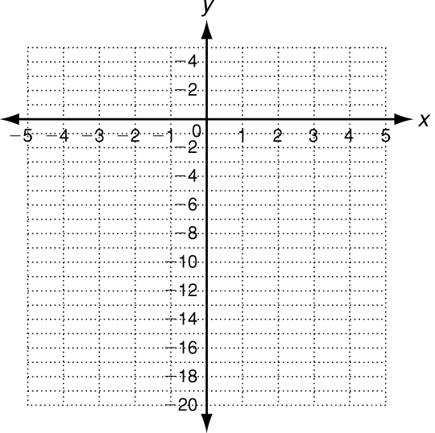
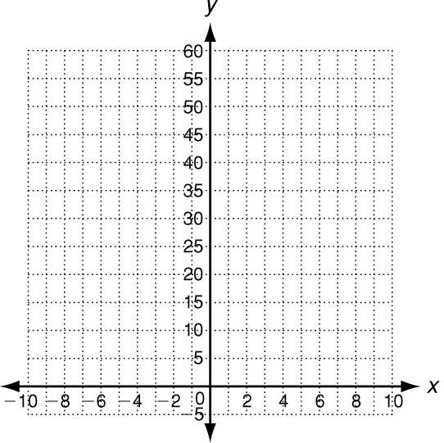

Domain:

Range:

Asymptote:
Domain:

Range:

Asymptote:
Domain:

Range:

Asymptote:

