Equations Day 1 Homework Name________________________________________

1. $\frac{2}{25} ÷\frac{8}{5}$

2. -10 + 17

3. -10 – 17

4. -10 – (-17)

Solve each equation algebraically and visually (like we did with boxes and apples)
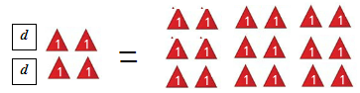
5. 2d + 4 = 18

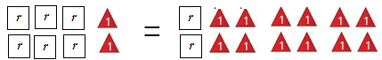
6. 6r + 2 = 10 + 2r

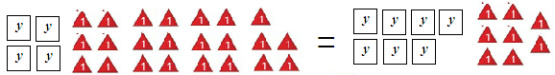
7. 4y + 23 = 7y + 8

8. Al’s father is 45. He is 15 years older than twice Al’s age.
a. Write an equation and define your variable.

b. How old is Al?

9. (Challenge – try your best!) Will is w years old. Ben is 3 years older than Will.

a. Write an expression, in terms of w, for Ben’s age. ___________________________

b. Jan is twice as old as Ben. Write an expression, in terms of w, for Jan’s age.

c. If you add together the ages of Will, Ben, and Jan, the total comes to 41 years. Form an equation and solve it to work out how old Will, Ben, and Jan are.

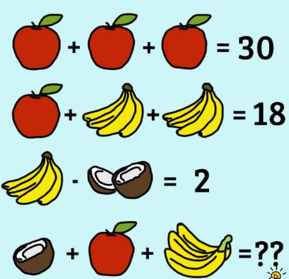

For the Thinkers:

